**Case for a Lower Threshold Voltage on Mayfly Stations**

**Background** – The threshold voltage is currently 3.55 Volts for uploading data via the cell modem. The [batterie](https://www.adafruit.com/product/328)s used for the LEC Stations (GMI_ECx) are 3.7 Volt with 2.5Ah capacity. These stations have been going below the 3.55 Volt threshold during cloudy days and winter months. The solution would seem to be higher capacity battery and larger solar panel or lower the threshold voltage. Tests have been run on LEC Station current draw and battery capacity tests.

These tests indicate that a lower threshold voltage should solve the problem. A station that has been upgraded to a 4G modem has been tested with the cutoff threshold set to 3.3 Volts and results show almost double the run time (with no battery recharge).

**Mayfly LEC Station test** – GMI_EC3 was upgraded to the 4G modem and the cutoff threshold was changed from 3.55 to 3.3 Volts. This changed the run time without solar recharge from less than 3 days to 9 days! The TSA plot shows a significant decrease in discharge rate as the Li-ion battery approaches 3.3 volts.

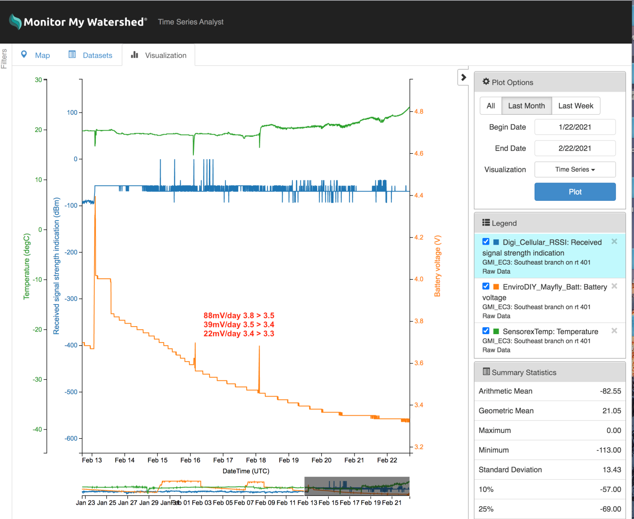

Figure 1 Mayfly sensor station battery voltage with no solar charging

**Li-ion battery tests-** A battery test protocol was set up as a mayfly program to control the charge and discharge of the battery under test. Tests were run with the following protocol:

* Start test with 20 ohm load on battery
* If less than 3 Volts wait 20 minutes and start battery charge at 0.5A
* When voltage reaches 4.2 Volts stop charge and wait 20 minutes and start discharge with 22? ohm load.
* When battery under test reaches 3 Volts stop discharge and wait 20 minutes and start charge.
* Repeat cycle with battery voltage recorded every 5 minutes.

Tests were run on a 3.7 Volt Li-Ion battery with 2.5 Ah rated capacity as shown on the chart in Figure 2.



Figure Typical Charge/discharge curve with a 2.5 Ah Li-Ion 3.7 Volt battery

Figure 3 shows the charge and discharge Ah to be roughly equal but somewhat below rated value of 2.5 Ah capacity. This may be due to ageing since the battery has been in service at least 6 months.



Figure Charge/discharge data

**Conclusion** – The discharge of the Sensor station shows that lowering the threshold to 3.3 Volts will more than double the run time to almost 10 days. The battery tests however would indicate about a 30% improvement in capacity. For some reason the quiescent draw of the station decreases significantly as battery voltage approaches 3.3 Volts yet the 4G modem is uploading consistently.